Water Scarcity

Why is Water Important?

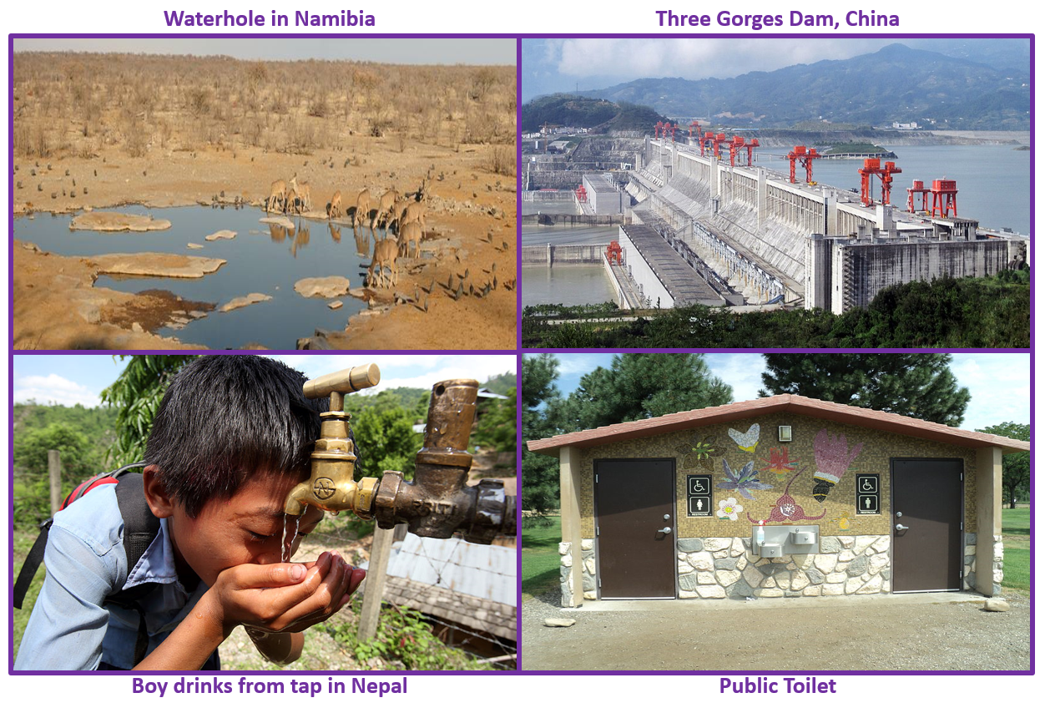

Water is a substance that is essential for supporting all life on our planet. Water is a key need for animal and plant life. A regular and reliable amount of water helps to maintain the balance within ecosystems. Water is vital for human survival and development. It is important for drinking, cleaning and sewage disposal.

With over 7 billion people on the planet, rising by an additional 80 million people each year, water management has never been more important or more challenging.
Finally, water power is becoming increasingly important in the generation of cheap, green energy.

Sources of Water

ACTIVITY: Match the key words (A-G) to the correct definition. Then match them to the correct picture (1-7).
LETTER | KEYWORD
A | Reservoir and dam
B | Aquifer
C | Borehole
D | Greywater
E | River Water
F | Desalination
G | Piped/ infrastructure

Definition | WHICH LETTER? | WHICH PICTURE?
An underground store of water. Water seeps into permeable rock (a rock that allows water to pass through). It percolates down until it hits impermeable rock, where it sits in an underground lake.
The relatively clean wastewater from baths, sinks, washing machines, and other kitchen appliances.
Water is transported to homes and businesses through a network of pipes that are regularly maintained.
A deep, narrow hole made in the ground to locate water stored in aquifers.
Water is stored in a large, artificial lake behind a gigantic man-made concrete wall. This water store can be used at times of shortage or during periods of increased demand.
Fresh water carried by streams and rivers.
The process of removing salt from water. This is often done in large scale industrial plants.
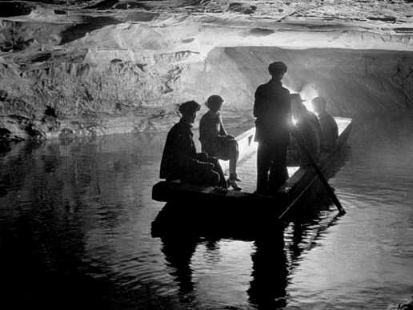
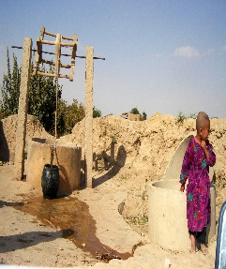
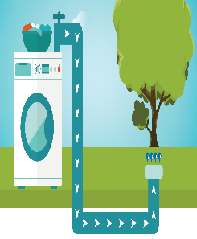
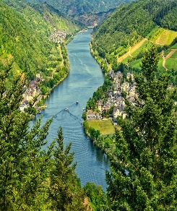
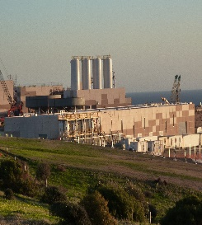
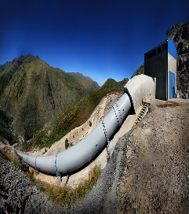
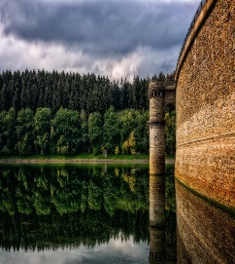
1
2
3
4
5
6
7

How do humans use water?

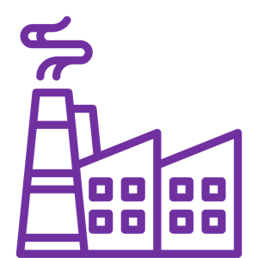
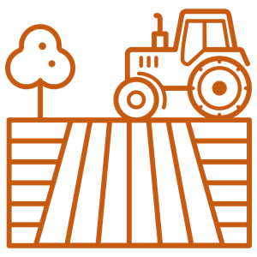
DOMESTIC USE
Domestic = to do with the home.
7.8 billion people use water each and every day in their homes for cooking, bathing, washing clothes, hygiene, and sanitation.
INDUSTRIAL USE
Industrial = to do with work and manufacturing e.g. mining, making cars or making electronics.
Water is used in most manufacturing processes - some big water uses are in making paper and petrol. Water is especially important in producing electricity.
AGRICULTURAL USE
Agriculture = to do with farming.
Water is essential in food production through irrigation (artificial watering of crops) and meat production. Irrigation is the single biggest use of water around the world. Without it we would not be able to produce enough food.

How do countries at different levels of development use water?

ACTIVITY: Use the information provided to complete the pie charts for the UK, Mali and India.
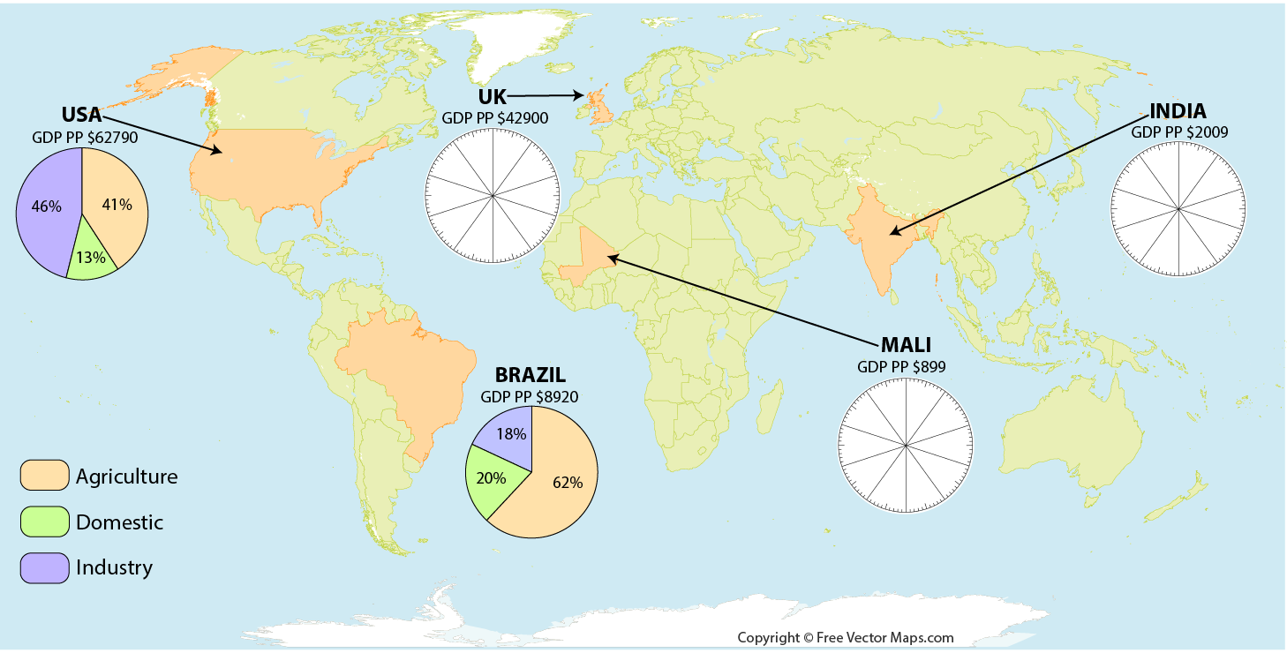
UK (Agriculture 3%, Domestic 23%, Industry 75%)
MALI (Agriculture 90%, Domestic 9%, Industry 1%)
INDIA (Agriculture 86%, Domestic 9%, Industry 5%)

ACTIVITY: Use the map above to complete the following sentence.
Generally, the more developed a country is, the sector that will consume the most water is….This is proven by the examples…
_________________________________________________________________________________________________________________________________________________________________________________________________________________________________________________________________________

Less developed countries use the majority of water for… This is proven by the examples of…
____________________________________________________________________________________________________________________________________________________________________________________________________________________
One sector that never uses more than a quarter of a country’s water use is….
_____________________________________________________

Suggest reasons why…
… Mali uses a greater proportion of water for agriculture and farming.
_________________________________________________________________________________________________________________________________________________________________________________________________________________________________________________________________________

… UK uses a greater proportion of water for Industry.
_________________________________________________________________________________________________________________________________________________________________________________________________________________________________________________________________________

… UK is likely to uses a greater proportion of water in energy production.
_________________________________________________________________________________________________________________________________________________________________________________________________________________________________________________________________________
… UK uses a greater proportion of water in the domestic sector than Mali.
_________________________________________________________________________________________________________________________________________________________________________________________________________________________________________________________________________

Water Scarcity
Scarcity= A shortage; or in short supply.
Water Scarcity= the lack of sufficient available water resources to meet the demands of water usage within a region.
Physical Water Scarcity= there is not enough water to meet both human demands and those of ecosystems to function effectively
Economic Water Scarcity= a lack of investment in water (infrastructure) or a lack of human capacity to satisfy the demand for water, even in places where water is abundant. Poor water management.
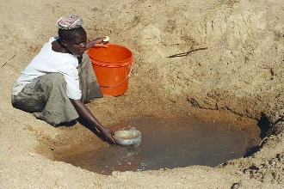
FACTFILE
- Approximately 1.1 billion people have no access to clean, reliable water.
- 4 billion people suffer from severe water scarcity for at least 1 month each year.
- 700 million people could be displaced due to water scarcity by 2030.
- For a number of reasons, populations suffering from water scarcity are likely to increase in coming decades.

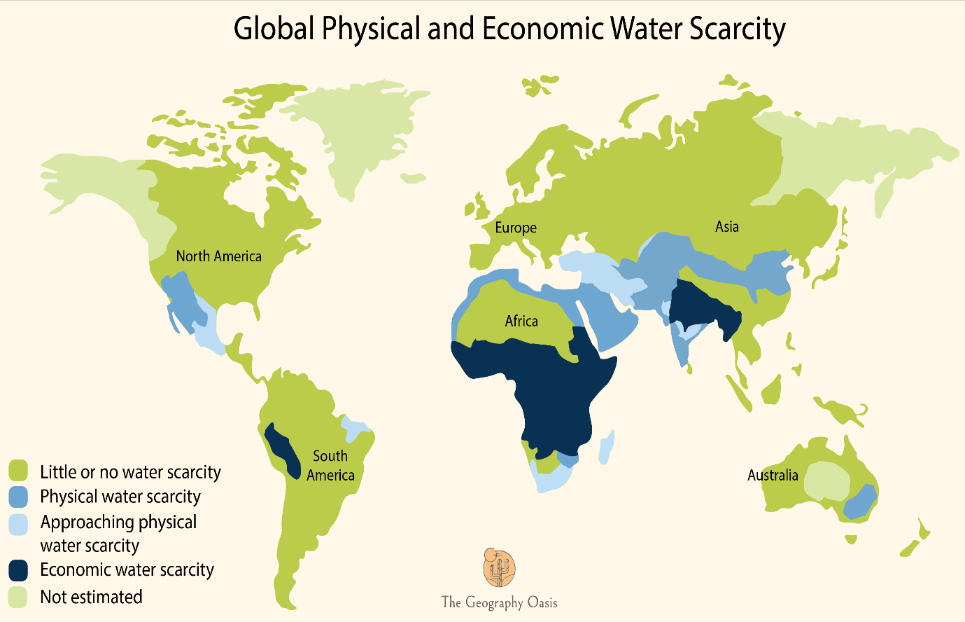

ACTIVITY: Study the map above and answer the following questions.
Describe the distribution of regions of the World that experience physical water scarcity. Circle the correct options below:

- Northern coastline of Africa
- Northern Europe
- USA-Mexico border
- South-West Australia
- Central Africa
- Northern China

Describe the distribution of regions of the World that experience Economic water scarcity. Circle the correct options below:
- Europe
- Sub-Saharan Africa
- Northern India and parts of central Asia
- North-East South America (Brazil}
- Central-Western South America around Peru, Ecuador

A Map to show the World’s Major Climatic Zones
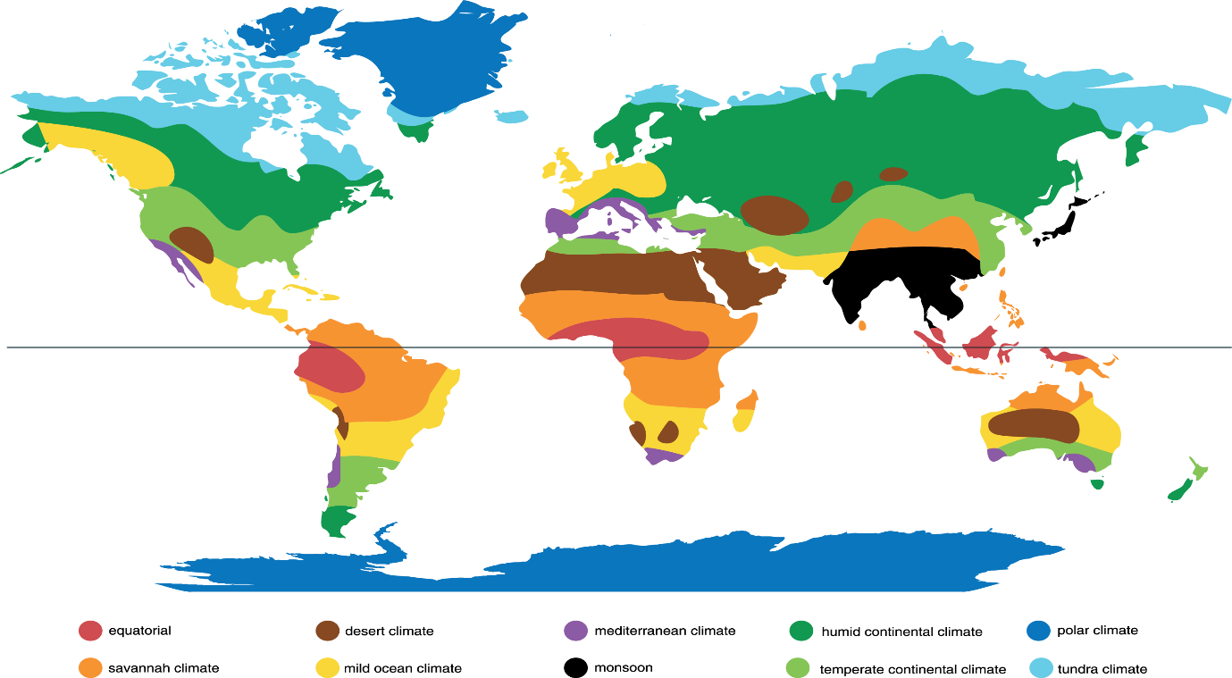

Describe the relationship between the location of areas of physical water scarcity and the distribution of global climates.
____________________________________________________________________________________________________________________________________________________________________________________________________________________

A Map to show the Gross Domestic Product per Capita (a measure of wealth)
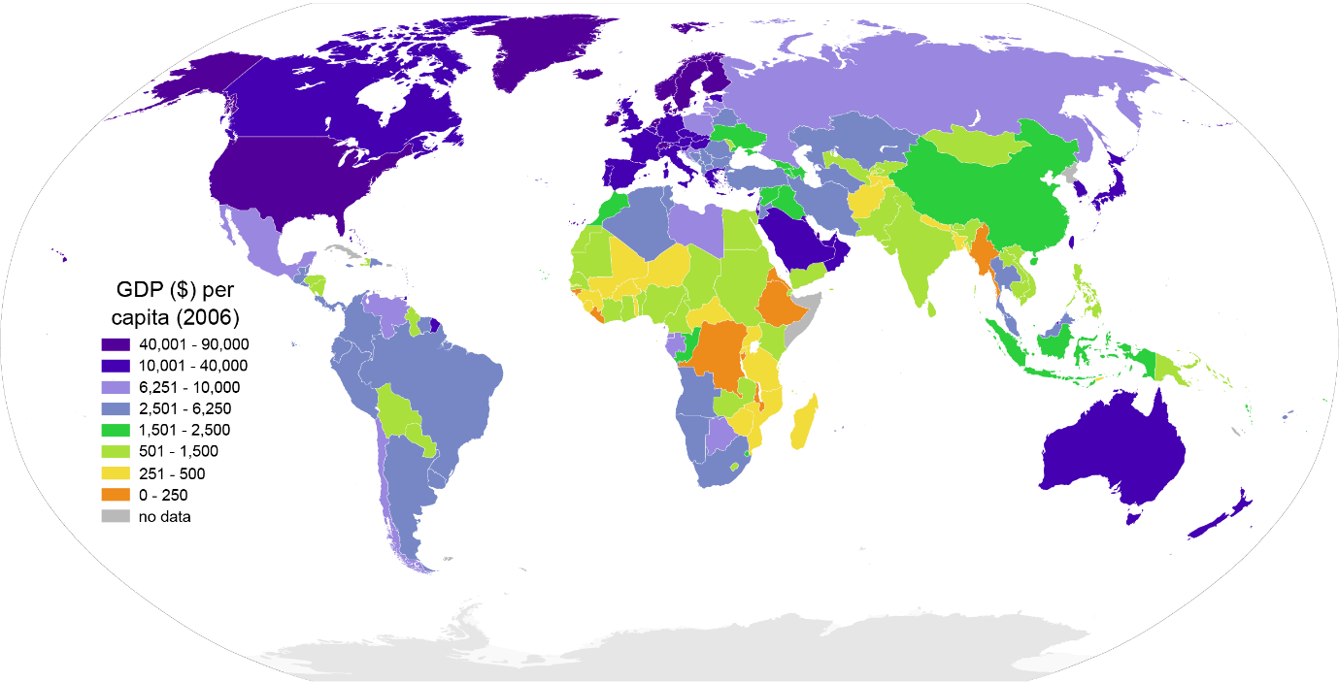

Describe the relationship between the location of areas of economic water scarcity and GDP per Capita.
____________________________________________________________________________________________________________________________________________________________________________________________________________________

Water scarcity is a global problem that is set to increase in coming decades. Freshwater withdrawals have tripled over the last 50 years. Demand for freshwater is increasing by 64 billion cubic meters a year (1 cubic meter = 1,000 liters). Why is this a growing problem?

ACTIVITY: Unscramble the anagrams to discover the reasons for increased water scarcity. Match this to a KEY FACTS box by drawing an arrow to the correct box. Finally, add the correct secondary impacts into the correct box.
Causes of increased scarcity (anagrams)
UOIOPLAPTN WTGOHR
POPULATION GROWTH

TCMELIA NCGEHA

GRICRELTAUU

LLPOUNTIO

CEIOCNMO EMETVDLONPNE

KEY FACTS | SECONDAY IMPACTS
This process is resulting in more droughts and more evaporation of surface storage water.
Rivers are becoming increasingly under threat due to effluent from factories and eutrophication from farming.
This is increasing by 80 million each year. Water is finite and cannot be increased. | 5, 7
People are becoming richer and therefore demanding more water to support their lifestyles and products.
Water is used for irrigation. Much of this is wasted due to inefficiencies and poor practices.

 | SECONDARY IMPACTS TO ADD TO TABLE
1 | Longer droughts will push people off the land and increase migration.
2 | Increasing political conflict over who is to blame and how this global issue should be addressed.
3 | Manufacturing, shops, tourism require water.
4 | Water is essential for agriculture so a lack of it can affect crop yields.
5 | The finite water supply has to be distributed across more people.
6 | Businesses may relocate to guarantee water resulting in negative impacts on the economy of some areas.
7 | This fuels urbanization and cities will demand more water to provide for services.
8 | Results in higher prices of food for consumers.
9 | it kills organisms that depend on these water bodies.
10 | Cholera and diseases as a result of poor drinking water from contaminated waters.
11 | Livestock may die.
12 | People may have to drink contaminated water

Finite= limited or a set amount.
Drought= A prolonged period of time without significant rainfall.
Irrigation= Supplying water to the land to help crops to grow.
Effluent= liquid industrial waste or sewage discharged into a river or the sea.
Eutrophication= an excess amount of nutrients from fertilizers being put into a body of water, which causes algal blooms to grow.

Water Scarcity Case Study: High Income country, Large Scale, High-tech: Singapore
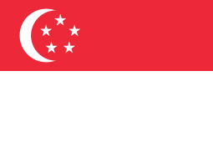
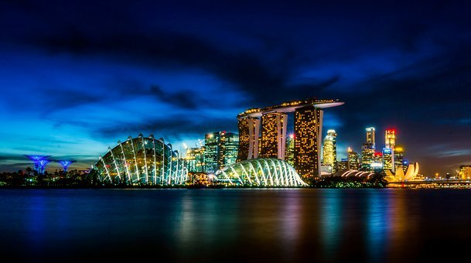
Why is providing water a challenge in Singapore?
Singapore is a relatively small island that is home to 6 million people and rising. Singapore’s population density of 7257 people/km² is ranked the third most dense in the world. Although this is a tropical equatorial climate that receives 2350mm of rain annually, it does suffer from a lack of space to collect and store rainwater.
Rain does not fall evenly over the year and the country experiences periods of drier weather. Water demand in Singapore is currently about 430 million gallons a day. That is enough to fill 782 Olympic-sized swimming pools, with homes consuming 45% and the non-domestic sector taking up the rest. By 2060, Singapore's total water demand could almost double in line with growing population and wealth.

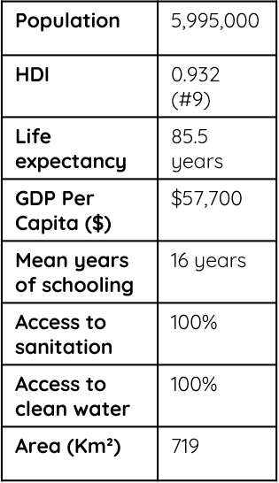

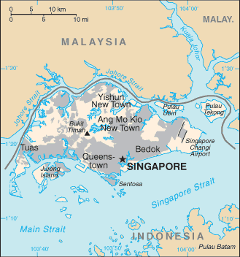

Potential Solutions:

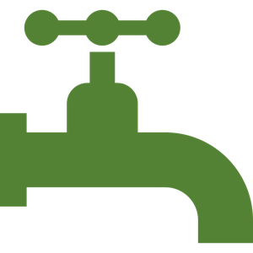
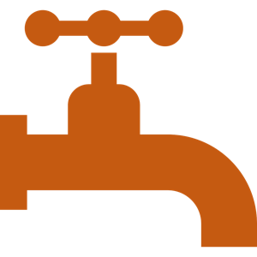
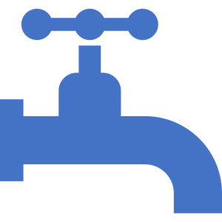
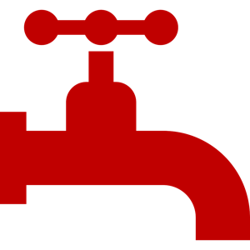

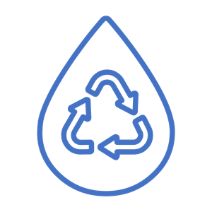

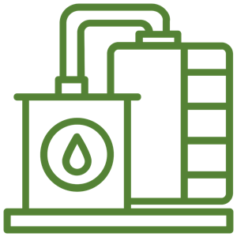
TAP 1: Catching and storing rainwater
TAP 2: Importing rainwater from Malaysia
TAP 3: NEWater
TAP 4: Desalination
Singapore signed 2 water agreements with neighbors Malaysia in the early 1960s. Fresh water is piped on to the island from the Malaysian state of Johor. This provides 250 million gallons of water each day. The agreement will run until 2061, however, it is uncertain if it will be continued beyond this date
Stormwater runoff is now captured from two-thirds of Singapore’s land area and stored in seventeen reservoirs throughout the island for subsequent use. They are supported by an incredible network of infrastructure. The reservoirs receive discharge from approximately 7 000 km of man-made drains and canals.
Five NEWater plants now provide 60 million gallons of water each day, which meets 30% of Singapore’s water demands. The NEWater plants accept treated wastewater and then further treat this wastewater using a three-stage process that includes microfiltration, reverse osmosis, and ultra-violet disinfection to produce water that meets World Health Organization drinking water standards. However, most of the treated water is used in industrial processes.
Singapore currently has three desalination plants with a combined capacity of 130 million gallons a day that can meet up to 30% of Singapore’s current water demand. Two more desalination plants will be ready by 2020. Desalinated water is expected to meet up to 30% of Singapore’s future water needs by 2060.

ACTIVITY: Study the case studies from Singapore and Ethiopia. Use them to answer the following questions:
- Why might many Singaporean’s be concerned about importing a large percentage of their water needs from another country?
____________________________________________________________________________________________________________________________________________________________________________________________________________________

Water Scarcity Case Study: Low Income Country, small-scale, Low-tech- Konso, Ethiopia

Why is providing water a challenge in Ethiopia and the village of Konso?
Located in southwest Ethiopia, the Konso highlands are an impressive upland landscape covering over 200km² and home to approximately 235,000 people. Much of Ethiopia’s agricultural land is situated above 1500m on steep and highly erodible slopes. This steep landscape, in combination with flash flooding, can result in significant downslope soil erosion. This a dry and warm climate with an annual average rainfall of 507mm. However, some months average less than 20mm of rain. When rains do arrive, they can be short and intense leading to flash flooding. Overall, there is limited rainfall that falls quickly on to steep surfaces that drain away the water rapidly. This makes collecting and storing water for domestic and agricultural use incredibly challenging.

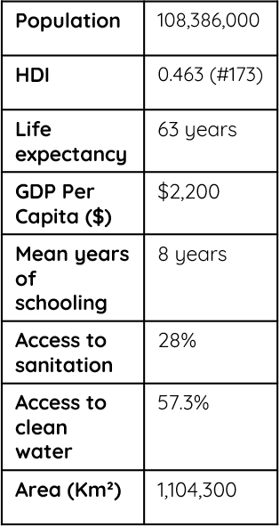

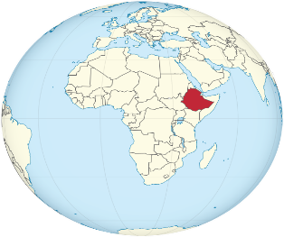

Potential Solutions:
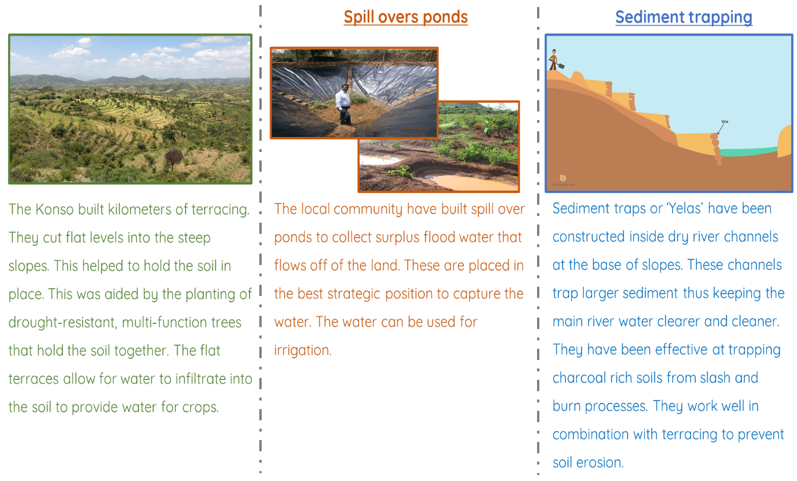
2. ‘Water shortages in Konso are more to do with physical factors rather than economic factors.’ To what extent do you agree? Give reasons for your answer.
____________________________________________________________________________________________________________________________________________________________________________________________________________________
__________________________________________________________________________________________________________
3. The examples of water management in Konso, Ethiopia, are described as ‘low-tech’. From studying those examples, suggest some of the key features of low-tech approaches:
_________________________________________________________________________________________________________________________________________________________________________________________________________________________________________________________________________

